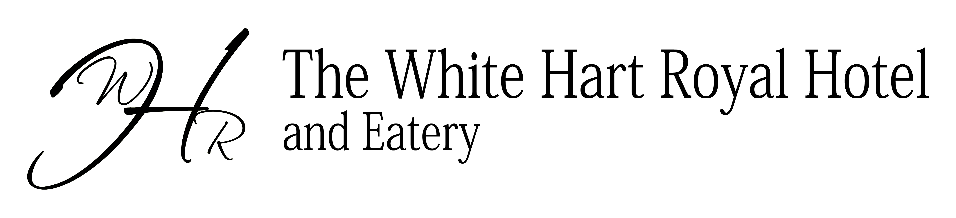
SOUS CHEF

The White Hart Royal Hotel is part of the award winning Coaching Inn Group (Publican Award winner for Best Employer and Best Accommodation Operator). The hotel is located in the centre of the historic market town of Moreton in Marsh in Gloucestershire.

The salary and benefits:
. Competitive salary
. Laundered Chef whites
. Share of tips, generous staff discount and company perks
. 28 days Annual leave
. Pension Scheme
. Possible live-in with this position

The job role:
. To support our Head Chef and to help lead and develop the team
. Produce great, fresh, quality dishes prepared to our high standards
. Be involved in the planning and implementation of our menus
. Ensure great stock control and food safety standards

The chef:
. A really good communicator with excellent leadership qualities
. Possesses a commercial approach and able to achieve good G.P.
. Leads by example with a’ hands-on’ approach
. Good computer literacy skills, ideally experienced with Pro Wizard
. Possess a real passion for food and high quality presentation standards
. Experienced in catering for Weddings and Conferences
. Excellent understanding and implementation of Stock Control, Food
Safety, HACCP and Health & Safety

Apply for this position to: L.charity@innmail.co.uk

Please only apply if your skills and experience closely match our requirements.
www.coachinginngroup.co.uk

